**Introduction to Programming**

**Project Proposal**

**Student ID and Name:**  64011599 Run Chantrapipat

**Project Title:** Chat App

**Background and Motivations**

-First of all, there are many chats app in our world that can access to the social but I would like to create my own chat app because I think it would be cool to create chat application. In this app, you can send a massage not only one to one person but also parties massage. You can control who will have access to the server.

**Requirements**

Summarize what your program will be able to do.

1. Private chat or Group chat
2. You can clear chat history any time and can save an old chat history
3. Real time conversation

**Examples**

Describe a few examples of how the program interacts with the user. You may include a mock-up of the interface of your program.

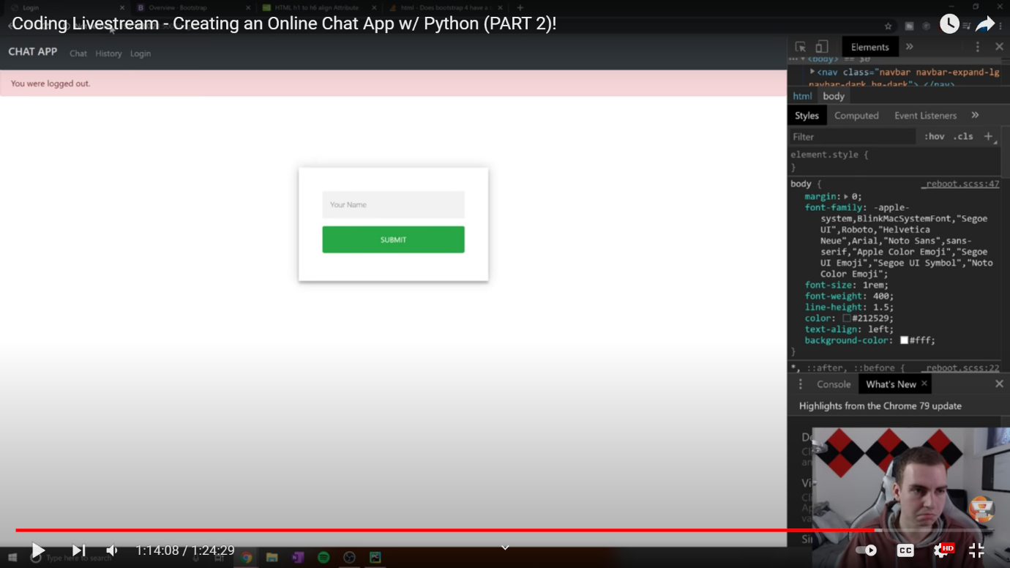-First, user join the server then enter your name, after that you can start chatting with people in the same server. You can clear chat history any time. In contrast you can save chat history and look for chat history any time.